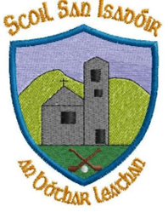
11/03/2024
Dear parents,
With just two weeks to the Easter holidays I would like to draw your attention to the following items:
I would like to congratulate all our students on their super efforts for World Book Day. Sincere thanks to 5th & 6th class for organising a very well run book fair raising over €240 for GAZA.
FAI soccer schools tournament
Congratulations to our ladies soccer squad whose soccer final took place today in St. Kevins , Littleton. Thanks to Ms. Sharon for taking the time to roll this out with 5th and 6th. Well done to all involved.
Primary Games
Well done to all our students in 6th who took part in the Primary Games trials under the guidance of Ms. Sharon and Ms. Kay. Best of luck and congratulations to Niall, Albert, Clodagh and Clíona who will be representing our school in this year’s primary games.
Seachtain na Gaeilge
Lá Ghlás will take place on Friday the 15th of March. Children can dress in green for the day. Please do not buy anything new. This event is part of seachtain na gaeilge where children will be taking part in lots of activities as Gaeilge over the coming days and right up to the Easter Holidays on the 22nd of March. It is not a fundraising event.
Reminder: School is closed on Monday 18th of March

Parents Council Cake Sale
The Parent’s Council annual cake sale will take place on Sunday 17th March following 10am mass. Please contact the PA for further details and if you wish to volunteer. We would love to see you there on the day. Thanks again for all your support. All funds raised are spent on valuable education resources for all children.

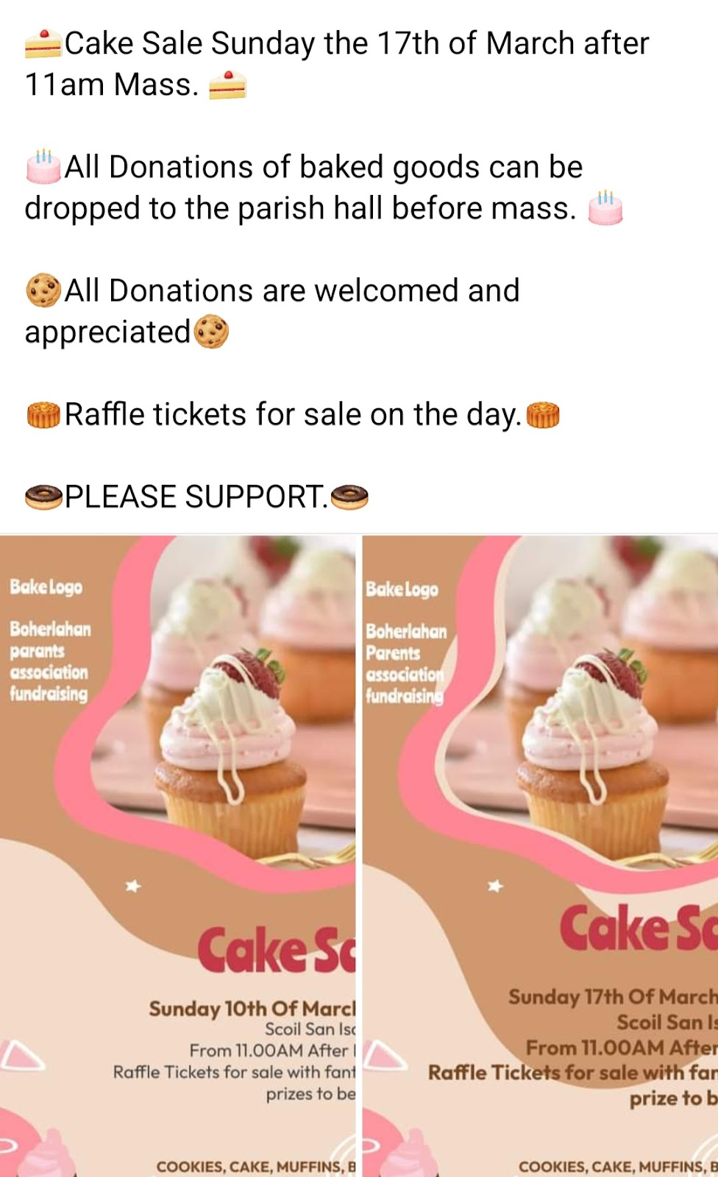

Heart to Hand
Sincere thanks to all who supported the Heart to Hand initiative so far which is still ongoing if you wish to support it.

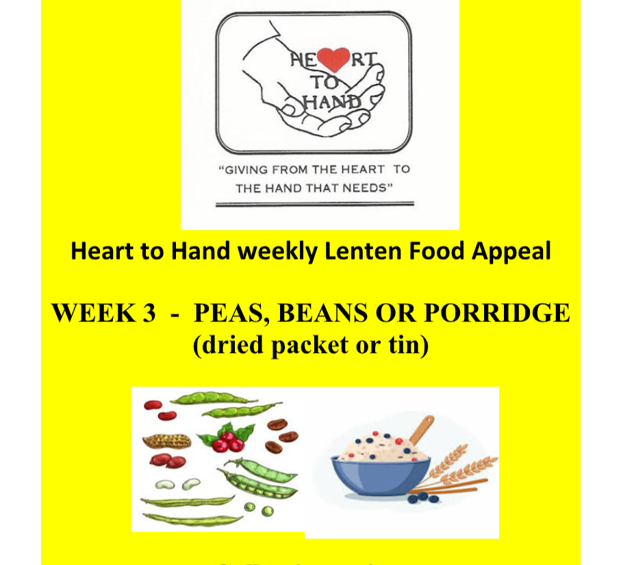

As always, please do not hesitate to contact me should you have any questions.
Dates for your diary
La Ghlás 15th March
First Holy Communion Mass 17th March
Cake Sale 17th March
School holidays 22nd March
First Holy Communion 18th May
Kind regards,
Catherine Cleary
Principal

